Assignment 1.3 - Composer API Goals.

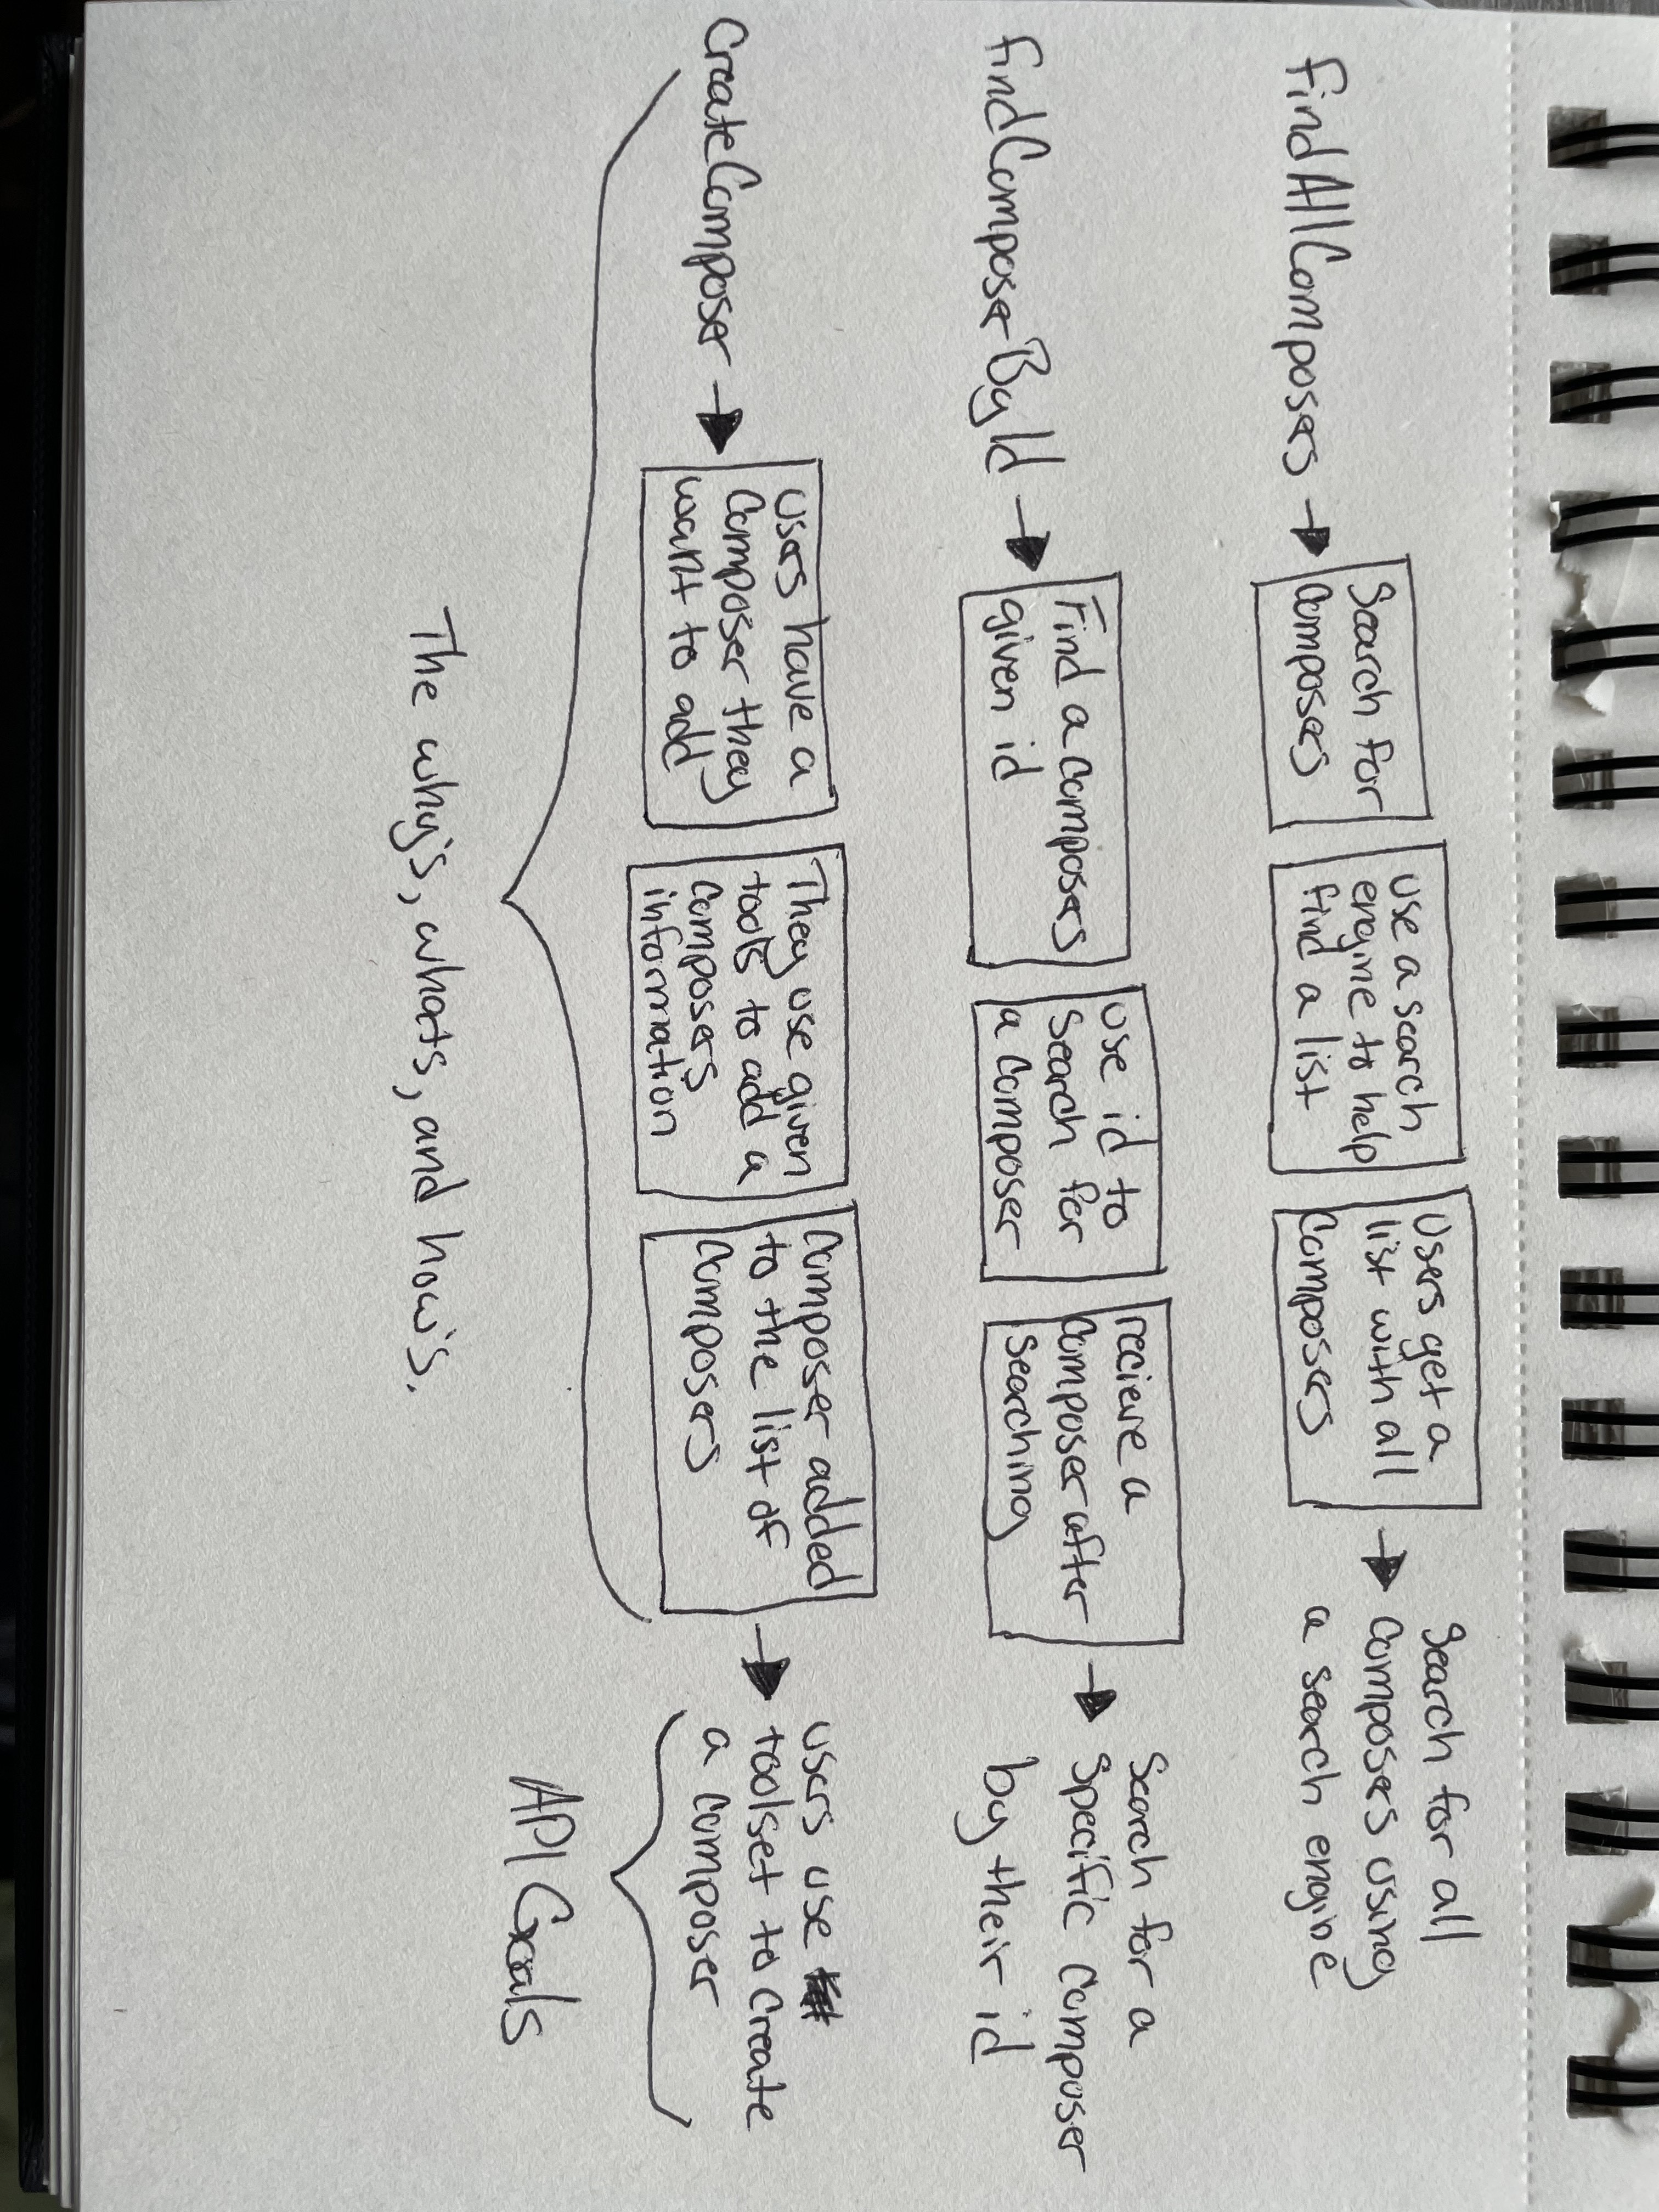

The above flowchart shows a general guide on how a user may want to complete the stated function to the left.

* findAllComposers – A user who wants to search for every composer would more than likely just search for a general list of composers or click on an “overall” list of composers provided by whatever site or application that they’re on.
* findComposerById – When composers are given an ID, for example, Pachabel [222960], then a user can use the provided ID to search for Pachabel and get all results matching him.
* createComposer – Any user that needs to create a composer, or add them to a list, would usually be provided a toolset that they can then use to add all of the necessary information.